Integrating and Implementing Technology Final Project

**Name:** Ross Nicol and Kristen Jones

**Lesson Plan Title:** The Three Branches of Government Introduction

**Describe audience, context, constraints:** The audience includes 23 4th grade students. There is a wide range of socioeconomic status within these 23 students. 5 of these students are on Individual Education Plans for Reading. These students may require accommodations when reading material. When applicaple, the teacher will read text aloud. When students are offered opportunities for independent reading, these students will be permitted to use the Google Extension-Read&Write for Google Chrome. This is an extension that is pre-loaded on student Chromebooks and allows for students to highlight text, which the extension will then read aloud. The time constraint for this lesson is one hour and thirty minutes.

**Objectives/Indicators**

|  |  |  |  |
| --- | --- | --- | --- |
| **Objectives** | **Ohio New Learning Standards** | **ISTE Standards for Students** | **Assignments/Assessments** |
| Students can explain the roles of the three branches of government, including the legislative, judicial, and executive branches | 19. A constitution is a written plan for government. The Ohio Constitution and the U.S. Constitution separate the major responsibilities of government among three branches. |  | * Pre/post quizizz * Nearpod formatives   + 4 Multiple choice questions   + Written response on executive branch   + Picture representation of Judicial Branch   + Written response on Legislative Branch   + Nearpod quiz   + Nearpod poll |
| Students will complete reseach through the Nearpod website in order to explain the powers of the Legislative Branch |  | Knowledge Constructor  3a - Students plan and employ effective research strategies to locate information and other resources for their intellectual or creative pursuits. | * Written response on the Legislative Branch |
| Students will complete multiple assessments where they recieve immediate feedback. Students will use their feedback to improve and adjust their practice in the future. |  | Empowered Learner  1c Students use technology to seek feedback that informs and improves their practice to demonstrate their learning in a variety of ways. | * Pre/post quizizz * Nearpod formatives   + 4 Multiple choice questions   + Written response on executive branch   + Picture representation of Judicial Branch   + Written response on Legislative Branch   + Nearpod quiz   + Nearpod poll |
|  |  |  | * Written response on the Legislative Branch |

Ohio Learning Standards for Social Studies:

Government Strand: Roles and Systems of Government

19. A constitution is a written plan for government. The Ohio Constitution and the U.S. Constitution separate the major responsibilities of government among three branches.

Student friendly ‘I can’ Statement

I can identify and explain the roles of the three branches of government.

Content Elaboration from the Ohio Social Studies Model Curricula

A constitution is a written document describing the way a government is organized and how its power is allocated. The Ohio Constitution and the U.S. Constitution separate the major responsibilities of government among three branches. Responsibilities of the three branches include:

• legislative branch makes and passes laws;

• judicial branch interprets and applies laws; and

• executive branch carries out and enforces laws.

EXPECTATIONS FOR LEARNING Identify the three branches of government and the responsibilities of each branch of government

ISTE Standards

Empowered Learner

1c Students use technology to seek feedback that informs and improves their practice to demonstrate their learning in a variety of ways.

Knowledge Constructor

3a - Students plan and employ effective research strategies to locate information and other resources for their intellectual or creative pursuits.

**Prior Knowledge/Prerequisites**

Prior to this lesson, students must have knowledge of the term ‘constitution’. They must understand that the constitution is written document that describes how the government is organized. This will be touched on multiple times prior to this lesson, including the wrap up of The American Revolution Lesson and The Contitution and The Bill of Rights Lesson. Students must also be connected to the Nearpod account in order to access the information and assessments.

**Assessment**

**Pre-Assessment**

Three Branches of Government Quizizz <https://quizizz.com/admin/quiz/583f193041305b20755e474a>

The technology for this pre-assessment allows for immediate feedback to students and educators. It is also very engaging for students. With each question they answer, they are given a popular meme. They are also awarded points and the top three students make it to the digital podium. The element of competition adds to the engagement. This also directly aligns to the content standard. Students will a Reading IEP will be permitted to use the Read&Write for Google while completing this assessment.

**Formative and Summative Assessments**

Formative Assessments

* Nearpod Formative Assessments:<https://share.nearpod.com/yI2qrlql63>

Students will be assessed periodically through the Nearpod Lesson. This assessment has been chosen because it allows for immediate feedback to the teacher allowing for the immediate correction of student misconceptions. It has also been chosen because students will remain engaged because they know they are responsible for producing material that shows what they learned throughout the lesson.

* + After watching a short intoductory video, students will answer 4 multiple choice questions on the three branches of government.
  + After reading a short text and viewing an organizer on the Executive Branch, students will share what they know about the Executive Branch
  + After watching a short video on the Judicial Branch, students will draw a picture that repesents the branch.
  + After exploring a website on the Legislative Branch, students will share what they know about the branch on a shared didital forum within Nearpod.
  + To finish the Nearpod lesson, students will complete a short quiz on the Nearpod site.
  + Students will then complete a poll to show where they feel their knowledge of the three branches of government is based on a 1-3 scale: 1 meaning I am still confused and may need a little help, 2 being I understand but could still use some practice, and 3 I understand and could teach the information to someone else.

Summative Assessment

Three Branches of Government Quizizz <https://quizizz.com/admin/quiz/583f193041305b20755e474a>

This is the same assessment as the pre-assessment. This has been chosen because it will allow teachers and students to see directly how the Nearpod lesson supported students in reaching their learning objectives. Students will be able to compare how they did on the pre-assessment before the lesson to how they did on the post assessment. This holds students accountable for their learning by showing them how engagement can impact their performance.

*Students will a Reading IEP will be permitted to use Read&Write for Google while completing this assessment.

**Models of Instruction/Instructional Strategies**

This lesson has been designed with the TPACK Model in mind.

* Technology-The technology chosen is age appropriate and supports students in meeting their objectives.
* Pedagogy-The pedogogical strategies implemented in this lesson include multiple of Marzano’s 9 Effective Instructional Strateies. These include:
  + Reinforcing Effort and Providing Recognition
    - Throughout the lesson student answers will be shared with all students within the Nearpod forum. The teacher will provide recognition and encouragement as the lesson goes on.
  + Nonlinguistic Representation
    - Throughout the Nearpod lesson, students will analyze 2 different advanced organizers on the Branches of Government. They will also share their knowledge of the Judicial Branch by drawing a picture
  + Setting Objectives and Providing Feedback
    - I can statements will be shared at the beginning of the lesson so that students have a clear understanding of their goals. Students wil then be provided immediate feedback through pre-assessments, formative assessments, and summative assessments throughout the lesson.
* Content-Content has been determined by the Ohio Learning Standards for Social Studies. The reading and video content chosen supports the mastery of these standards.

**Procedures/Activities**

The procedures for this lesson are as follows:

1. Students will complete the pre-assessment on the quizizz website.
2. As a whole group, students will participate in the Nearpod lesson. The Nearpod lesson procedures are as follows:
   1. Students will watch a short video on the The Three Branches of Government
   2. Students and teacher will analyze an organizer on the three branches of government
   3. Students will individually complete a 4 question quiz over the content of the video. Once all students are done, there will be a discussion on the answers and misconceptions will be addressed.
   4. The teacher will read a short paragraph about the Executive Branch, then provide an advanced organizer depicting the role of the Executive Branch, which students and teacher will analyze as a whole group.Once all students are done, there will be a discussion on the answers and misconceptions will be addressed.
   5. Students will watch a short video on the Judicial Branch.
   6. Students will draw a picture represnting the Judicial Branch. Once all students are done, there will be a discussion on the answers and misconceptions will be addressed.
   7. Students will be given time to explore a website on the Legislative Branch.
   8. With a partner students will provide a short answer on what they learned about the Legislative Branch. Once all students are done, there will be a discussion on the answers and misconceptions will be addressed.
   9. Students will complete a poll describing their knowledge of the branches of government.
3. Students will complete the post assessment on the quizizz website.
4. Students will be given time and guidance to compare their pre-assessment score to their post assessment score and share thoughts on why their score improved, did not improve, or stayed the same.

**Identify and Discuss Technological Decisions**

**Resources**

All of the content resources for this lesson are technology based. The following websites and videos will be used within the Nearpod lesson. They have been chosen because they provide age appropriate, engaging information that will support students in their progress to mastering the lesson objectives.

* 3 Branches of Government Video
  + <https://www.youtube.com/watch?v=OvwlRTYvU8o>
* Executive Branch Text
  + <https://government.mrdonn.org/executivebranch.html>
* Judicial Branch Video
  + <https://www.youtube.com/watch?v=9giPmCWnepU>
* Legislative Branch Website
  + <https://www.ducksters.com/history/us_legislative_branch.php>

**Technology Resources**

SmartBoard

This resource will be used to display the Nearpod lesson to the students. This will be the avenue in which the videos, student, responses, and learning materials will be viewed. It has been chosen because it is readily available in classrooms in the district and is easy to use.

Student Chromebooks

Students will complete all assessments through their Chromebooks. The Nearpod lesson that will be shown on the Smartboard also connects to student chromebooks and allows them to answer questions and follow along. This has been chosen because the Chromebooks are provided to all students in our district.

Google Read&Write Extension

This tool will be used by students with an I.E.P. in reading. They will use it when they are required to complete independent reading, whether it be in the Nearpod platform, on websites, etc. It has been chosen because it is an easy to use tool that students are familiar with, as they have used it perviously in the year. To use this extension, students can click on a word they do not know and the extension will read it aloud to them. They can also read entire questions. Whatever the students highlight, the Read&Write App will read it aloud.

Quizizz

<https://quizizz.com/admin/quiz/583f193041305b20755e474a>

This technology was chosen because it is an assessment tool that provides immediate feedback to studens and teachers. It is engaging for students as it allows for fun memes to be shared with students as they answer each question, based on if they answered correctly or incorrectly. It also adds an element of competition to further engage students.

Example of Quizizz Student View

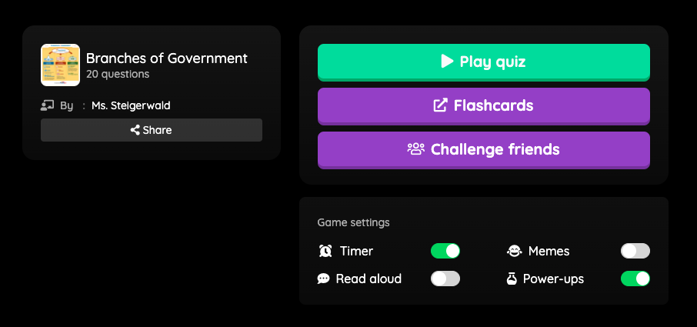

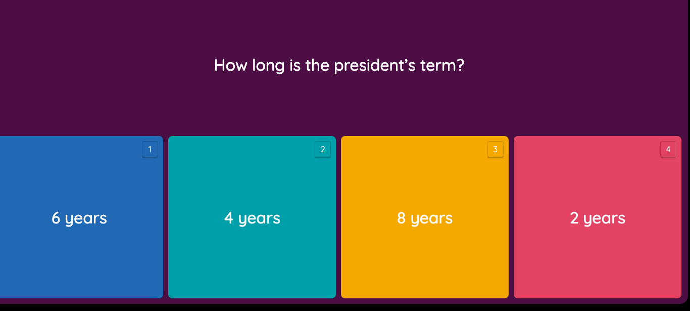

Nearpod

<https://share.nearpod.com/yI2qrlql63>

This technology resource is like a powerpoint presentation, however it is much more interactive and engaging. This will guide students through the content and allow the teacher to assess their progress through periodic checkins within the Nearpod website. This has been chosen because it allows the content to be shared on the Smartboard while students follow on their Chromebooks. It allows students to participate in multiple forms of formative assessments which provide instant feedback to the teacher, who can then provide immediate feedback to students and address misconceptions right away. This is an engageing technology that will hold student attention, as well as allow them to share their knowledge in multiple forms, providing opportunities for success to all different types of learners.

Example of Formative Assessments within Nearpod (Student View)

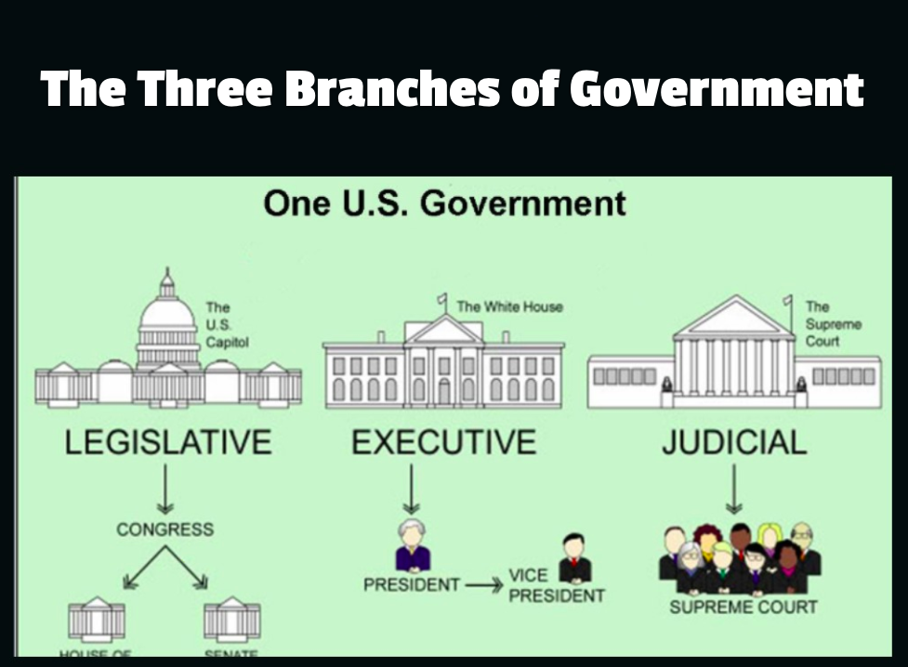

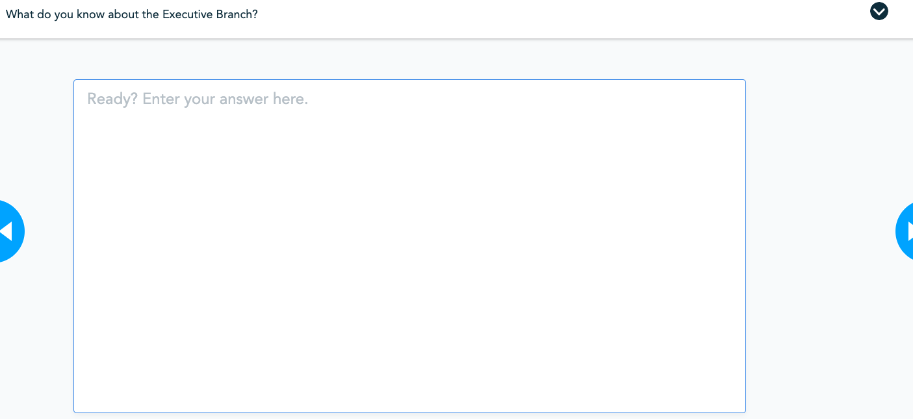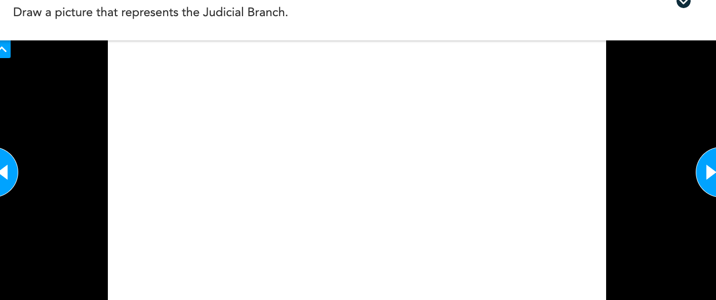

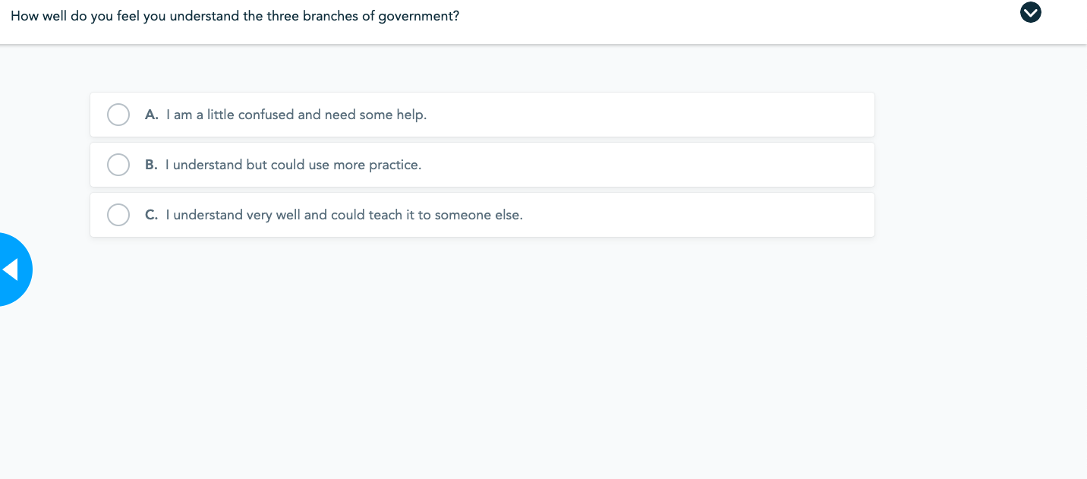

**Lesson Reflection**

In our lesson, our first focus was the final assessment. First, we made sure that our final assessment addressed the Ohio Content Standard. Once we were sure that our final summative assessment did this, we planned our lesson to help students be successful on the summative assessment, therefore, showing mastery of the standard. TPACK certainly played a major role in our planning. We focused on the standard first to make sure that the rest of our plan directly addressed this. The pedogogical and technological pieces of our plan was created simultaneously, as we ensured that the technology would support our teaching strategies.

With TPACK in mind, we feel that the development of planning with technology is much more content focused, as opposed to simply using technology just to use technology. TPACK reminds us that we must always focus on the standards, and that our teaching strategies and technology choices should always circle back to this. The use of TPACK allows for more efficient use of time in the classroom where students are receiving quality information in an engaging setting. Where before, we may have tried a new technology just to use the technology, regardless of standards and if that technology truly supports the standard, we now keep in mind all three parts of TPACK to create lessons that truly support the needs of our students.

In order to appropriately see student progress in regards to the lesson based in technology, we compared our pre-assessment scores with our post assessment scores. We chose to keep our pre and post assessment the same. This way we would see a direct corolation between scores after teaching our lesson. Unfortunately, due to remote learning we were unable to complete the lesson the way it was intended. Our lesson using Nearpod relied on multiple formative assessments and immediate teacher feedback and corrections within the lesson. This is not possible to do with remote learning. If we were to assume the scores of our students during the pre-assessment on Quizizz on the Three Branches of Government, our expectations would be very low. This is not a topic students are taught in depth previously, so they most likely do not have a lot of background knowledge on the subject. The majority of answers on the pre-assessment would be guesses. During our Nearpod lesson, there were 3 formative assessments, one on each branch of government. During this we expect to see most students on track, but we also expect to see some misconceptions. This is good, because it gives us the ability to address them immediately. For our post assessment, we expect to see students earn a score of C or higher. We expect that all students will significantly increase their score from the pre-assessment.

Predicted Example of Student Data

|  |  |  |  |
| --- | --- | --- | --- |
| Student | Pre-Assessment Score | Post-Assessment Score | Teacher Notes |
| 1 | 50% | 75% |  |
| 2 | 40% | 70% |  |
| 3 | 60% | 80% |  |
| 4 | 45% | 80% |  |
| 5 | 55% | 70% |  |
| 6 | 30% | 60% | *Student did not reach goal of C or higher. Small group interventions needed |
| 7 | 60% | 85% |  |
| 8 | 65% | 75% |  |
| 9 | 70% | 90% |  |
| 10 | 35% | 70% |  |
| 11 | 20% | 50% | *Student did not reach goal of C or higher. Small group interventions needed |
| 12 | 55% | 75% |  |
| 13 | 45% | 75% |  |
| 14 | 60% | 85% |  |
| 15 | 60% | 80% |  |
| 16 | 25% | 65% | *Student did not reach goal of C or higher. Small group interventions needed |
| 17 | 70% | 90% |  |
| 18 | 55% | 70% |  |
| 19 | 40% | 70% |  |
| 20 | 60% | 80% |  |
| 21 | 65% | 85% |  |
| 22 | 65% | 85% |  |
| 23 | 50% | 70% |  |

In reflection, althought we were not able to complete the lesson, we feel that it would have been successful overall. One item that should be explained is that this is an introductory lesson. We would continue instruction on this lesson and dive deeper into each of the three branches of government in future lessons. The final assessment scores would help us to develop these future lessons, because we would continue to analyze the data to see which branch students understood and which they did not understand. We could then focus future instruction based on the analysis. Also, as noted in the teacher notes of the predicted data, we expect that some students may not meet the goal of a ‘C’, 70%, or higher. These students will receive small group reteaching in order to set them up for success as the unit continues.